3rd Annual Frank Wise bike ride information

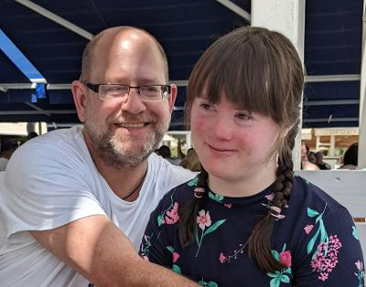

What’s happening

The Route
- Starting at The Griffin Inn, Chipping Warden, 10.00, Saturday, 9th July. OX17 1LB. Please be ready to ride at 9:45.
- Midway point for refreshment/ toilet, The Crown Inn at Stockton, CV47 8JZ
- Finish at the Griffin Inn, back in Chipping Warden
- The route can be downloaded / exported to a gps device from the link below:
https://www.komoot.com/tour/r230687348

- If you don’t have a device then please make sure you let Dave know and he’ll ensure you can partner up with someone on the day.

Equipment
Please ensure that you bring the following;
- Helmet
- Puncture repair kits/spare tubes
- Water bottles
- Waterproofs (see the weather forecast here)
- A mobile phone

Riding
- Plan to go out in small groups and stay in bubbles to maintain social distancing.
- No pressure on time, we anticipate the ride to take between 2 and half / 3 and half hours
- Steve and Paul will be manning the water stop at Stockton, in the pub car park.
- If you breakdown and can’t fix the bike, we have a back-up vehicle; ring James on 07542 471786.

Joining the Justgiving page
- https://www.justgiving.com/fundraising/david-kelly70

